

Event Management

Business Requirements

|  |
| --- |
|  |
| *Strictly Private and Confidential* |
|  |
|  |

Version Control

|  |  |  |  |  |
| --- | --- | --- | --- | --- |
| Date | Version | Author(s) | Shared with | Remarks |
| 20-Apr-18 | 0.1 | * Udyan Sharma | * Neha Malik * Deepak Mendiratta | * Initial Draft |
| 11-May-18 | 0.2 | * Neha Malik | * Udyan Sharma | * Suggestive Remarks |
| 16-May-18 | 1.0 | * Udyan Sharma | * Neha Malik * India IT | * Incorporated review comments |
| 24-July-18 | 1.1 | * Shefali Patel |  | * Rearranged Requirements to club BR with UI and added Requirements from BR_0116 To BR_0128 |

Table of Contents

Version Control 2

***1.*** ***Executive Summary*** 4

***1.1.*** ***Project Background*** 4

***1.2.*** ***Project Objectives*** 4

***1.3.*** ***Project Scope*** 5

***1.3.1.*** ***In Scope*** 5

***1.3.2.*** ***Out of Scope*** 5

***2.*** ***Business Requirements*** 6

***2.1.*** ***Process Description*** 6

***2.2.*** ***Functional Requirements*** 13

***Requisition Phase*** 13

***Sourcing Phase*** 18

***Execution Phase*** 22

***Billing and Feedback Phase*** 22

***2.2.1.*** ***User Interface Requirements*** 25

***2.2.2.*** ***Reporting Requirements*** 65

***2.2.3.*** ***Security Requirements*** 67

***2.2.4.*** ***Audit Requirements*** 67

***2.3.*** ***Non-Functional Requirements*** 68

***Requirements Traceability Matrix*** 69

***Appendix*** 70

***Definitions, Acronyms, and Abbreviations*** 70

***References*** 70

1. ***Executive Summary***
   1. ***Project Background***

This project has been proposed to resolve the challenges faced by PwC India Event Team while organizing the events for PwC stakeholders. As of now there are lot of operational challenges in Event Management process right from planning phase to execution phase. The expectation from this project is to have a well-controlled and streamlined Event planning process which can be monitored in real-time manner, and the event execution could be done by a 3rd party with PwC India Event team governing the execution process.

The major pain-points which are the driving force of this project are:

| S. No. | Pain – Point |
| --- | --- |
| 1. | Adhoc nature of capturing details regarding the event from the initiator due to which changes in event requirement details can happen even at very late stages of the planning process. This leads to disorientation for both event team and the event initiator. |
| 2. | The overall process is not streamlined in the manner that adherence to requisite approval process is maintained every time, or adherence to TAT is maintained for each step, or exceptions are handled gracefully, or proper roles/responsibilities are defined for exclusive execution of process step, or financial reporting can be done seamlessly through Precision. |
| 3. | The intelligent dashboard analytics and monitoring of in-flight process flow instances to management is not there due to unavailability of information regarding events in a real-time manner. |

* 1. ***Project Objectives***

The main objective of the final product (which shall be achieved upon completion of this project) is to streamline the event planning and execution process so that the process runs within the defined policy frameworks and exceptions are identified & managed in a graceful way. The capabilities desired from the final product are as:

1. Digitization of Event Planning Process right from event requisition, approval workflows, automated notifications and escalations, vendor liaising, payment processing etc.
2. Real-time process monitoring and governance of both event planning and event execution process.
3. Intelligent Analytics and dashboard capabilities for providing useful insights.
   1. ***Project Scope***

The scope of this project includes digitizing all parts and activities of Event Management process unless it is specifically mentioned as Out of Scope.

* + 1. ***In Scope***
* Event Requisition with all requisite details (hotel and event activities) by any PwC India employee.
* Approval workflow for event requisition.
* Generating and distributing RFQ to vendors.
* Generation of comparative cost summary based on proposals from all vendors.
* Vendor selection and contract signing.
* Complete billing process.
* Feedback on event post event execution.
* Real-time dashboard and analytics.
* Modular and configurable approach towards managing different sections of the event requisition. At present only Hotel and Event sections will be available and other sections like Transport and Giveaways will added later on, but the system shall be designed in such a way that both Hotel and Event sections can be treated as individual modules.
  + 1. ***Out of Scope***
* As of now, the event requisition process would be available for only hotel and event activities from both planning and execution perspective. The other sections like Transport, Giveaways etc can be added later on in second phase.

1. ***Business Requirements***
   1. ***Process Description***

The event management process is composed of 4 major phases:

1. Event **Requisition** Phase
2. Event **Sourcing** Phase
3. Event **Execution** Phase
4. Event **Billing** and **Feedback** Phase

Lifecycle of the event can be depicted as –

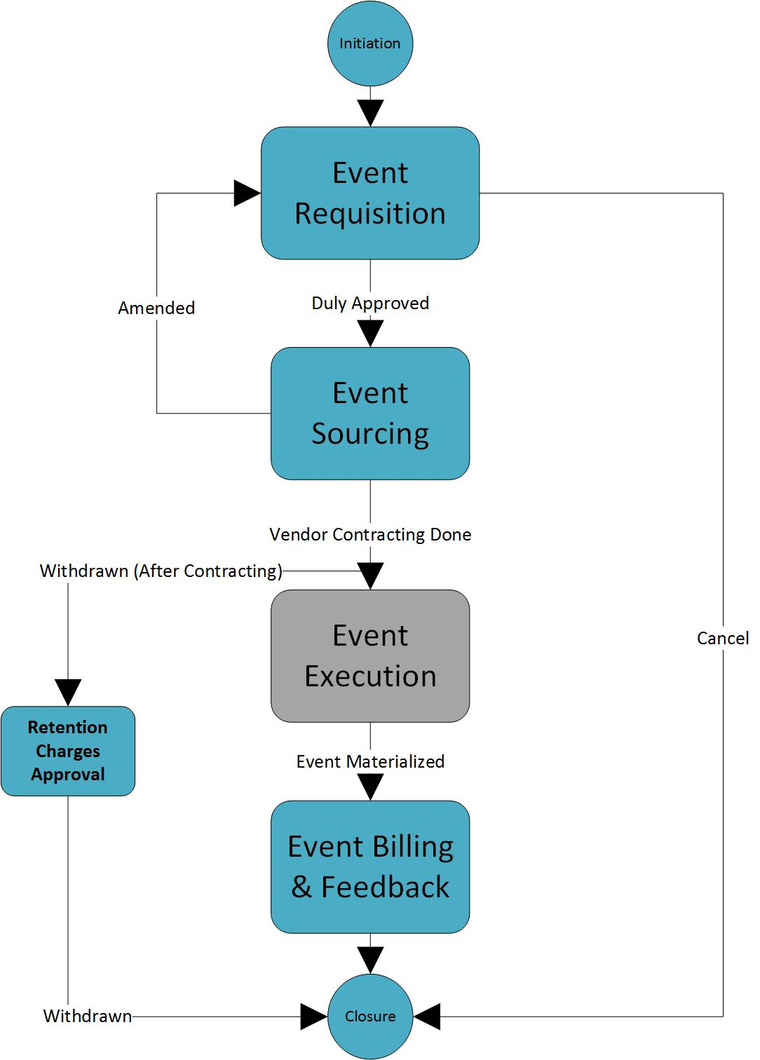

And there are stages/statuses in the life-cycle of event requisition:

1. **New/Draft** – Requester is in the process of raising the event requisition or has saved draft version of it but not yet submitted the event requisition.
2. **Submitted** – Event Requester has submitted the requisition for necessary approvals.
3. **Approved** – The requisition has been duly approved.
4. **Cancelled** – The requester has cancelled the event requisition, this will mark the closure of the requisition.
5. **Requirements Concluded** – The detailed requirements for the event has been concluded between the event requester and event team.
6. **Vendor Contracting Completed** – The contract has been finalized with the vendor for event execution based on the requirements.
7. **Amended** – The requirements for the event has been updated post requirements conclusion but before vendor contract could be finalized.
8. **Withdrawn** – The event requisition has been withdrawn after vendor contracting has been done but before event execution has started, this will mark the closure of the request.
9. **Hold** – The event requisition has been put on hold by the event manager because there is no event SPOC available to process the requisition.
10. **Executed** – The event has been successfully executed.
11. **Billing Completed** – The payment to vendor is successful.
12. **Feedback Provided** – The event requester has provided the feedback on the event.
13. **Completed** – The event requisition has been closed via normal completion.

**Event Requisition Phase:**

1. Event Requester raises the requisition by providing mandatory information.
2. The requisition goes through approval process depending on the event type like client events such as NED event, CFO conclave, Tax Symposium requires approval by project partner, LOS Operations Leader and Markets Leader. Some internal events like Offsite requires approval by project partner and LOS Operations leader while most of the internal events requires approval of project partner only.
3. Post approval, the event SPOC will conduct a meeting with event requester to capture finer details about the event.
4. After the requirements (Hotel and Event) are finalized, **RFQ** is generated which is like the final output of event requisition phase.

**Note** – The event requisition process can be put ON HOLD by the event manager in requisition phase if there is no event SPOC available to process the requisition.

The event requisition can be cancelled anytime by the event requester during the requisition phase.

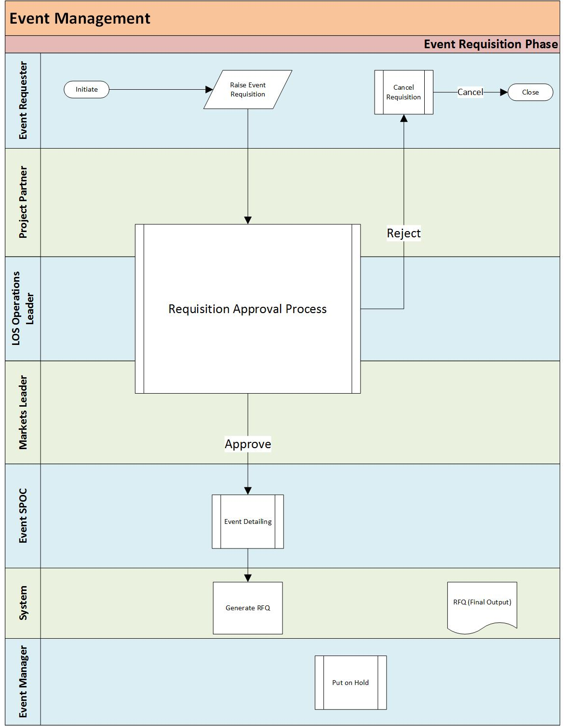

**Event Sourcing Phase:** The event requisition will go through the event sourcing phase (described below) only if vendor sourcing is going to be handled by the events team, otherwise the sourcing process will be managed in **iProcurement** (Precision) by the Sourcing team.

1. The event SPOC shares the RFQ with the vendors, the RFQ for hotel and RFQ for event requirements will be sent separately. For vendors having year-round contracts with the firm RFQ need not be sent, only request for availability will be sent.
2. Each vendor reviews the RFQ and sends a proposal as response for RFQ.
3. Upon receipt of proposals from the vendor, a **comparative cost summary** is generated for both types of RFQ (hotel and event).
4. The comparative cost summary is sent by the event SPOC to the event requester so that s/he can make a selection for each type vendor (hotel and event). The event SPOC also shares their recommended choice (L1 vendor) as well along with the comparative cost summary.
5. The event requester reviews the comparative cost summary and selects a vendor each for hotel and event requirements so that event SPOC can have a further discussion by the vendor.
6. The choice of vendor (for both hotel and event) by the event requester goes through the approval process as described below –
   1. **No approval** if selected vendor by event requester is L1 vendor or selected vendor is someone other than L1 but the proposed cost by selected vendor is more than prescribed limit (say 10%) of the cost by L1 vendor.
   2. **Partner approval** if selected vendor is not L1 vendor and proposed cost by selected vendor is more than prescribed limit (say 10%) that of the cost of L1 vendor.
7. The event SPOC then conducts a meeting the selected vendor asking for NO-REGRET proposal.
8. The vendor will then submit a NO-REGRET proposal.
9. A **final cost summary** is generated based on the NO-REGRET proposal. The vendor will share the contract for official contract signing.
10. The project partner will approve the final cost summary.
11. The central signing authority will sign the contract with vendor being the other party. The vendor will receive the billing instructions post contract signing.

**Note** – The event requisition can be amended anytime during sourcing phase in following scenarios:

1. **Change in event requirements** – In this scenario, event requester will update the details in event requisition and sourcing phase will be restarted.
2. **Forced change** **due to unavailability**– In this scenario, event SPOC will inform the event requester regarding the unavailability of venue for desired dates and update the event requisition accordingly.

Also, the event requisition process can be put ON HOLD by the event manager in sourcing phase if there is no event SPOC available to process the requisition.

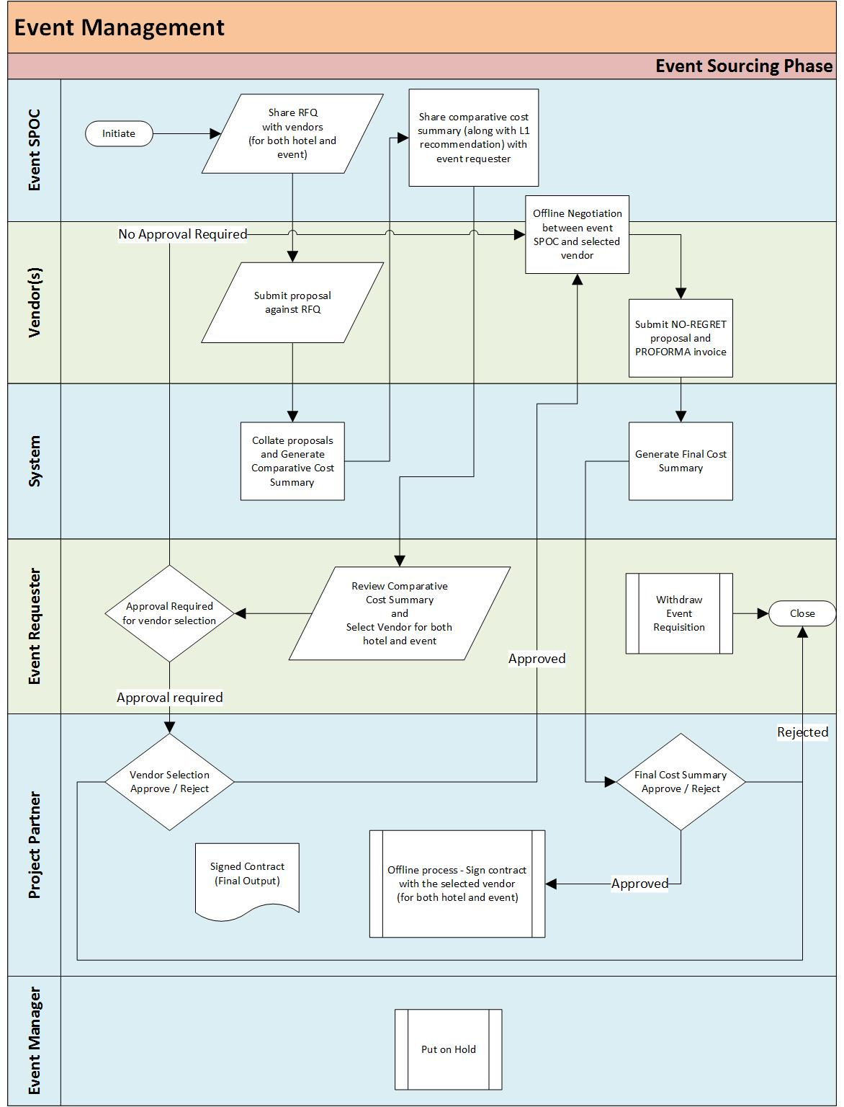

**Event Execution Phase:**

1. The event SPOC manages the overall of execution of the event by the vendor. This will be a completely offline phase and the event SPOC will just update the event requisition on successful completion of the event.

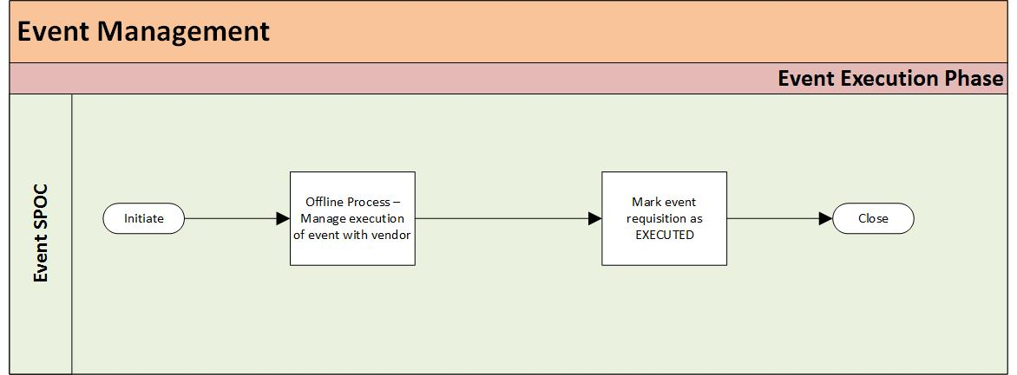

**Event Billing and Feedback Phase:**

1. Upon successful completion of the event, the vendor will be notified to provide invoices in the specified format.
2. The vendor will submit the invoices which will be sent to the event SPOC for approval.
3. Upon successful approval by event SPOC, the invoices will be shared with the CBT SPOC for approval.
4. Upon successful approval by CBT SPOC, the invoices will be shared with event requester for final review.
5. The event requester does the final review of the invoices and then invoices will be sent to the Finance Account Payables team for releasing payment to vendor.
6. The event requester will be notified to provide the feedback for the event.
7. Upon submission of feedback for the event requester, the event requisition will be marked as Complete.
8. If requester doesn’t provide feedback for the event, then s/he will not be allowed to raise another event unless s/he provides the feedback for old event requisition.

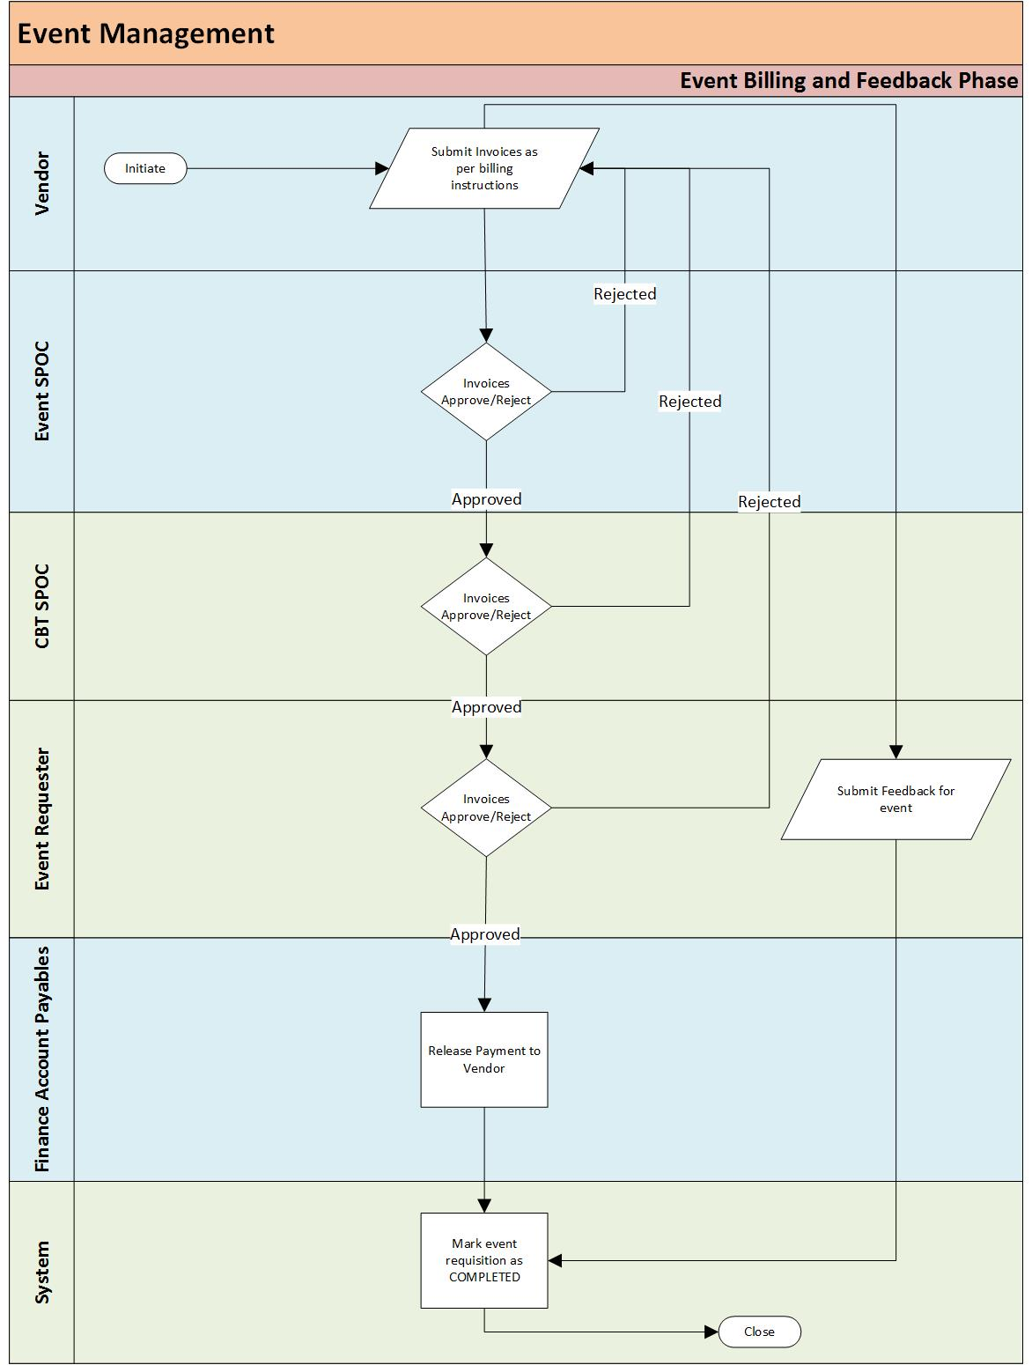

**Administration:**

There are certain activities of the process which would not be part of the event management process but would rather help in governance of the process. These are the activities which would be part of administration –

1. Enable/Disable different sections/modules of the event requisition to so that they can included/excluded during event management process.
2. Configuration of organization calendar so that working days/hours along with holidays could be set for the year.
3. Configuration of approval matrix for event requisitions.
4. Configuration of timer for different kind of escalations.
5. Configuration of parameters for automating decision making process (sourcing, execution, billing decisions) of event requisition.

The ability to enable/disable different modules as desired shall also be provided to the administrator, so that system is made configurable as described below:

*.*

* 1. ***Functional Requirements***

The requirements in this document are prioritized as follows:

|  |  |  |
| --- | --- | --- |
| **Priority** | **Rating** | **Description** |
| 1 | Critical | This requirement is critical to the success of the project. The project will not be possible without this requirement. |
| 2 | High | This requirement is high priority, but the project can be implemented at a bare minimum without this requirement. |
| 3 | Medium | This requirement is somewhat important, as it provides some value but the project can proceed without it. |
| 4 | Low | This is a low priority requirement, or a “nice to have” feature, if time and cost allow it. |
| 5 | Future | This requirement is out of scope for this project, and has been included here for a possible future release. |

***Requisition Phase***

***Creating a New Requisition Request:***

|  |  |  |
| --- | --- | --- |
| **Requirement No.** | **Description** | **Priority** |
| BR_0001 | Each PwC India employee shall have the access to submit a new event requisition. | 1 |
| BR_0004 | When an employee wants to submit a new requisition for event, s/he shall be able to provide following details :   * **Event Number** (Auto-generated number with current date for tracking) * **Event Name** * **Event Start Date (Option 1)** – Start date of the event (first choice) * **Event End Date (Option 1) –** End date of the event (first choice) * **Event Start Date (Option 2)** – Start date of the event (second choice) * **Event End Date (Option 2) –** End date of the event (second choice) * **Event Category** – Choose from the following options :   + **Internal (PwC Employees Only)**   + **External (Clients)** * **Type of Event** – Choose from the following options :   (In case **Internal** category is selected)   * + **Training**   + **Alumni Meet**   + **Family Day**   + **Annual Day**   + **Farewell Event**   + **Offsite**   + **Team Meet**   + **Partner's Meet**   + **Town hall**   + **Moderations**   + **X-LoS**   + **Strategy Meet**   + **Sports Day**   (In case **External** category is selected)   * + **Client Event**   + **Conclave**   + **Symposium**   + **NED Event**   + **CEO Summit**   + **Budget Event** * **Event Location** – Either single city or multi city with list of all Indian cities to choose from. * **Venue Category** – Choose from following options :   + **5 Star**   + **4 Star**   + **3 Star**   + **In house facility**   + **Party Lawn**   + **Stadium**   + **Clubs** * **Accommodation Required**   + **Yes**   + **No** * **Minimum Participant Count (Employees)** * **Maximum Participant Count (Employees)** * **Minimum Participant Count (Non-Employees)** * **Maximum Participant Count (Non-Employees)** * **Billing Options** – Choose from the following options :   + **Direct Billing**   + **BTC** * **Estimated Budget** – Calculated budget based on event dates, participant counts, event category. * **Cost Allocation** – Select single/multiple projects for allocating event cost, following fields shall be provided for each project :   + **LOS** (Select from List of Values)   + **SBU** (Select from List of Values)   + **Project Code** (Search and select from the list)   + **Project Name**   + **Task Code**   + **Task Location**   **Cost % split** (Informational message to be displayed – *Cost allocation will be on actual no. of participants at the time of event*) |  |
| BR_0005 | While submitting new event requisitions, following validations shall be adhered to :   1. **Selection of specific venue type based on event type:** The selection of venue type is restricted based on the selected event type. The selection of venue type shall be restricted as below :  |  |  | | --- | --- | | Selected **Event Type** (**External** Events) | **Venue Type** allowed | | Client Event | 5 Star | | Conclave | 5 Star | | Symposium | 5 Star | | NED Event | 5 Star | | CEO Summit | 5 Star |  |  |  | | --- | --- | | Selected **Event Type** (**Internal** Events) | **Venue Type** allowed | | Training | 5 Star and 4 Star | | Alumni Meet | 5 Star | | Family Day | In-House Facility and Party Lawn | | Annual Day | In-House Facility and Party Lawn | | Farewell Event | 5 Star | | Offsite | 5 Star and 4 Star | | Team Meet | 5 Star and 4 Star | | Partner’s Meet | 5 Star | | Town hall | 5 star | | Moderations | 5 Star, 4 Star and Clubs | | X-LoS | 5 Star | | Strategy Meet | 5 Star and In-House Facility | | Sports Day | Stadium |  1. **Selection of event dates based on event type and accommodation required:** The selection of event dates is restricted based on the selected event type as there is minimum lead time required for organizing different events so event start date shall be later than the minimum lead time for that event type.   The selection of event start date shall be restricted as below :   |  |  |  | | --- | --- | --- | | Selected **Event Type** | With **Accommodation** | Without **Accommodation** | | Training | 45 days | 15 days | | Alumni Meet | None | 45 days | | Family Day | None | 90 days | | Annual Day | None | 90 days | | Farewell Event | None | 15 days | | Offsite | 90 days | None | | Team Meet | 30 days | 15 days | | Partner’s Meet | 90 days | 15 days | | Town hall | None | 45 days | | Moderations | None | 30 days | | X-LoS | None | 30 days | | Strategy Meet | 45 days | 30 days | | Sports Day | None | 60 days |  1. **Selection of specific project and task Codes based on event type and event location**: The selection of project and task code is restricted based on the selected event type. The selection of project and task code shall be restricted as below :  |  |  |  | | --- | --- | --- | | Selected **Event Type** (**External** Events) | Type of **Project Code** allowed | Type of **Task Code** allowed | | Client Event | BD Code | Any | | Conclave | BD Code | Any | | Symposium | BD Code | Any | | NED Event | BD Code | Any | | CEO Summit | BD Code | Any | | Budget Event | BD Code | Any |  |  |  |  | | --- | --- | --- | | Selected **Event Type** (**Internal** Events) | Type of **Project Code** allowed | Type of **Task Code** allowed | | Training | Training Code | Any | | Alumni Meet | Internal Code | Any | | Family Day | Internal Code | Staff Welfare | | Annual Day | Internal Code | Staff Welfare | | Farewell Event | Internal Code | Staff Welfare | | Offsite | Internal Code | Staff Welfare | | Team Meet | Internal Code | Staff Welfare | | Partner’s Meet | Internal Code | Any | | Town hall | Internal Code | Any | | Moderations | Internal Code | Any | | X-LoS | Internal Code | Staff Welfare | | Strategy Meet | Internal Code | Any | | Sports Day | Internal Code | Staff Welfare |  1. **Selection of specific Billing Option based on event budget** : The billing option will be restricted based on the estimated event budget, the restriction shall be as below :  |  |  | | --- | --- | | **Estimated Budget** | **Billing Option** | | <= 25,000 | Direct Payment | | More than 25,000 | BTC |  1. **Selection of GST recoverable/non-recoverable event location**: If the selected event location is not a PwC office location, then a warning message shall be displayed to the event requester but submission of requisition shall proceed without any issue.   The warning message shall be like – *The event location chosen does not have any PwC registered office, hence there will be complete loss tax credit. The said amount shall be credited to respective SBU/LOS.*  The LOS Operations leader shall be notified about this tax credit loss and be informed to provide approval to absorb this loss. The event requisition shall be sent for further processing only after approval from LOS Operations leader. |  |
| BR_0008 | The event requester shall be able to cancel the requisition before it is submitted for approval. The cancellation action shall end the life cycle of the requisition. |  |
| BR_0009 | The event requester shall be able to submit the requisition only if s/he has adhered to guidelines in BR_0005 while providing details in event requisition. | 1 |
| BR_0007  BR_0008  BR_0009 | The event requester shall be allowed to take following actions on the event requisition :   1. **Save as Draft**: The event requester shall be able to save the requisition as draft, the validations described above shall not be forced in this action. 2. **Cancel**: The event requester shall be able to cancel the requisition, the life cycle of the event requisition shall end if this action is used. 3. **Submit**: The event requester shall be able to submit the requisition, all the validations described above shall be forced in this action.   The validation “**Selection of event dates based on event type and accommodation required”** shall not stop user from submitting the request, rather it shall be sent to event manager as an exception request. The requester shall get following warning message in this scenario –  “*This request is outside the limit of lead time to execute the event, it will be sent to event manager as an exception request and will either be accepted or reject based on their discretion*”  The validation “**Selection of GST recoverable/non-recoverable event location”** shall not stop user from submitting the request, rather the LOS operations leader shall be notified as listed above. |  |
| BR_0006 | The event requester shall be made aware of the required approval matrix the requisition shall pass through before it reaches the event team. The approval matrix is : (Below is the default matrix, however an Admin user shall be able to configure the approval matrix through Admin portal and the system shall follow the approval path set by the Admin user)   |  |  | | --- | --- | | **Selected Event Type** | **Required Approvals** | | Offsite | 1. Project Partner 2. LoS Operations Leader | | Partner’s Meet | 1. Project Partner 2. LoS Leader | | Tax Symposium | 1. Project Partner 2. LoS Leader 3. Markets Leader 4. Ethics Leader | | Client Events | 1. Project Partner 2. LOS Leader 3. Ethics Leader | | All Others | 1. Project Partner | |  |
| BR_0116 | If a user has requested a new request which is already in process of approval and the Admin changes the approval matrix for that event type then system shall consider the old approval matrix for inflight requests and follow new approval matrix for new requests that are made post the changes in the approval matrix. |  |
| BR_0010 | The event requester shall be notified (through email) about successful submission of the event requisition. This notification shall capture following data fields –   * **Event Number** * **Event Name** * **Requisition Submission Timestamp** * **Steps on how to access the details of event requisition** |  |
| BR_0011 | The project partner shall be notified (through email) that a new event requisition has been waiting for his/her approval. This notification shall capture following data fields –   * **Event Number** * **Event Name** * **Event Location** * **Event Start Date (Option 1)** * **Event End Date (Option 1)** * **Event Start Date (Option 2)** * **Event End Date (Option 2)** * **Estimated Budget** * **Requisition Submitted By** * **Requisition Submission Timestamp** * **Steps on how to access the details of event requisition**   **Note –** In case multiple projects are added in the event then approval notification shall be sent to the project partner of that project for which **Cost % split** is the maximum.  The project partners for other projects shall also receive **FYI notification** about the event requisition. |  |
| BR_0012 | The project partner shall be allowed to take following actions on the event requisition :   1. **Approve**: The project partner shall be able to approve the requisition for further processing. The project partner shall also be able to provide the approval comments. 2. **Reject**: The project partner shall be able to reject the requisition, the life cycle of the event requisition shall end if this action is used. The project partner shall also be able to mandatorily provide the rejection comments. 3. **Request More Info**: The project partner shall be to ask for more information from the event requester, if needed. The life cycle of the event requisition shall be put on hold if this action is used. |  |
| BR_0013 | The event requester shall be notified (through email) about the action taken by the project partner on the event requisition. This notification shall capture following data fields –   * **Event Number** * **Event Name** * **Action taken by the project partner** * **Comments provided by the project partner** * **Steps on how to access the details of event requisition** |  |
| BR_0014 | The event requisition life cycle shall end if action taken by project partner is Reject. |  |
| BR_0015 | The event requester shall be able to update the requisition/provide more information to the project partner and send it back to the project partner again for approval. (If action is Request More Info) |  |
| BR_0014  BR_0015 | In case action taken in BR_0012 is **Request More Info** then the event requester shall be able to update the requisition and provide comments as well. Then event requester shall be able to send the requisition to project partner again for approval.  In case action taken in BR_0012 is **Reject** then process flow for the event requisition shall be terminated.  In case action taken in BR_0012 is **Approve** then process will continue to function as described in subsequent requirements. |  |
| BR_0016 | In case the project partner doesn’t take any action on the event requisition within 8 working hours, then both the project partner and event requester shall be reminded (through email) that the said event requisition has been pending for project partner approval.  This notification shall capture following data fields –   * **Event Number** * **Event Name** * **Event Location** * **Event Start Date (Option 1)** * **Event End Date (Option 1)** * **Event Start Date (Option 2)** * **Event End Date (Option 2)** * **Estimated Budget** * **Requisition Submitted By** * **Requisition Submission Timestamp** * **Steps on how to access the details of event requisition**   This reminder notification shall be sent recursively after every 8 hours till the project partner takes action on the event requisition. |  |
| BR_0017 | Post Partner’s approval, if the event request type is **Offsite/Partner’s Meet/Tax Symposium/Client Event** it will go for LOS Operations leader approval or follow the approval path as defined through the admin portal.  The LOS Operations leader shall be notified (through email) that a new **Offsite/Partner’s Meet/Tax Symposium/Client Event** event requisition has been pending for his/her approval.  This notification shall capture following data fields –   * **Event Number** * **Event Name** * **Event Location** * **Event Start Date (Option 1)** * **Event End Date (Option 1)** * **Event Start Date (Option 2)** * **Event End Date (Option 2)** * **Estimated Budget** * **Requisition Submitted By** * **Requisition Submission Timestamp**   **Steps on how to access the details of event requisition** |  |
| BR_0018 | The LOS Operations leader shall be allowed to take following actions on the **Offsite/Partner’s Meet/Tax Symposium** event requisition :   1. **Approve**: The LOS Operations leader shall be able to approve the requisition for further processing. The LOS Operations leader shall also be able to provide the approval comments. 2. **Reject**: The LOS Operations leader shall be able to reject the requisition, the life cycle of the event requisition shall end if this action is used. The LOS Operations shall also be able to mandatorily provide the rejection comments. |  |
| BR_0019 | The event requester shall be notified (through email) about the action taken by the LOS Operations Leader on the **Offsite/Partner’s Meet/Tax Symposium** event requisition. This notification shall capture following data fields –   * **Event Number** * **Event Name** * **Action taken by the LOS Operations Leader** * **Comments provided by the LOS Operations Leader** * **Steps on how to access the details of event requisition** |  |
| BR_0020 | In case action taken in BR_0018 is **Reject** then process flow for the event requisition shall be terminated.  In case action taken in BR_0018 is **Approve** then process will continue to function as described in subsequent requirements. |  |
| BR_0021 | In case the LOS Operations Leader doesn’t take any action on the event requisition within 8 working hours, then both the LOS Operations Leader and event requester shall be reminded (through email) that the said **Offsite/Partner’s Meet/Tax Symposium** event requisition has been pending for LOS Operations Leader approval.  This notification shall capture following data fields –   * **Event Number** * **Event Name** * **Event Location** * **Event Start Date (Option 1)** * **Event End Date (Option 1)** * **Event Start Date (Option 2)** * **Event End Date (Option 2)** * **Estimated Budget** * **Requisition Submitted By** * **Requisition Submission Timestamp** * **Steps on how to access the details of event requisition**   This reminder notification shall be sent recursively after every 8 hours till the LOS Operations Leader takes action on the event requisition. |  |
| BR_0022 | Post LOS Operations leader’s approval if the event type is Tax Symposium, it will further go for Market Leader’s approval (System shall follow the approval process configured based on Event Type via Admin Portal)  The Markets leader shall be notified (through email) that a new **Tax Symposium** event requisition has been pending for his/her approval.  This notification shall capture following data fields –   * **Event Number** * **Event Name** * **Event Location** * **Event Start Date (Option 1)** * **Event End Date (Option 1)** * **Event Start Date (Option 2)** * **Event End Date (Option 2)** * **Estimated Budget** * **Requisition Submitted By** * **Requisition Submission Timestamp**   **Steps on how to access the details of event requisition** |  |
| BR_0023 | The Markets leader shall be allowed to take following actions on the **Tax Symposium** event requisition :   1. **Approve**: The Markets leader shall be able to approve the requisition for further processing. The Markets leader shall also be able to provide the approval comments. 2. **Reject**: The Markets leader shall be able to reject the requisition, the life cycle of the event requisition shall end if this action is used. The Markets shall also be able to mandatorily provide the rejection comments. |  |
| BR_0024 | The event requester shall be notified (through email) about the action taken by the Markets Leader on the event requisition. This notification shall capture following data fields –   * **Event Number** * **Event Name** * **Action taken by the Markets Leader** * **Comments provided by the Markets Leader** * **Steps on how to access the details of event requisition** |  |
| BR_0025 | In case action taken in BR_0023 is **Reject** then process flow for the event requisition shall be terminated.  In case action taken in BR_0023 is **Approve** then process will continue to function as described in subsequent requirements. |  |
| BR_0026 | In case the Markets Leader doesn’t take any action on the event requisition within 8 working hours, then both the Markets Leader and event requester shall be reminded (through email) that the said **Tax Symposium** event requisition has been pending for Markets Leader approval.  This notification shall capture following data fields –   * **Event Number** * **Event Name** * **Event Location** * **Event Start Date (Option 1)** * **Event End Date (Option 1)** * **Event Start Date (Option 2)** * **Event End Date (Option 2)** * **Estimated Budget** * **Requisition Submitted By** * **Requisition Submission Timestamp** * **Steps on how to access the details of event requisition**   This reminder notification shall be sent recursively after every 8 hours till the Markets Leader takes action on the event requisition. |  |
| BR_0117 | Once all the necessary approvals based on event type for event request are in place, the Requisition request will be assigned to an Event Manager. The event manager shall be able to assign an Event SPOC for further action on the Event. |  |
| BR_0047 | The event manager shall be able to put any event requisition on hold if there in no event SPOC available to cater the requisition. | 2 |
| BR_0027 | Once an Event SPOC is assigned to an event,  The event SPOC shall be notified (through e-mail) that a new event requisition (with all due approvals) has been pending for his/her action.  This notification shall capture following data fields –   * **Event Number** * **Event Name** * **Event Location** * **Event Start Date (Option 1)** * **Event End Date (Option 1)** * **Event Start Date (Option 2)** * **Event End Date (Option 2)** * **Estimated Budget** * **Requisition Submitted By** * **Requisition Submission Timestamp** * **Steps on how to access the details of event requisition** |  |
| BR_0028 | The event SPOC shall be able to enhance the event requisition by capturing more minute details regarding the event based on his/her discussion with the event requester. The event requisition shall capture following details :  **Hotel Details:**  **No. of Residential Rooms:** There shall be option to provide category-wise no. of residential rooms for each event day. This information shall be required only if **Accommodation required** is **Yes**   |  |  |  |  | | --- | --- | --- | --- | | **Event Day** | **No. of Single Rooms** | **No. of Double Rooms** | **No. of Triple Rooms** | | Day 0 |  |  |  | | Day 1 |  |  |  | | Day 2 |  |  |  |   **Seating Style:** Choose any of the following –   * Cluster/Round Table * Theater * Board Room * Class Room * U Shape   **Venue Timing:** Choose any of the following –   * 9 am – 6pm (Morning Slot) * 7:30 pm – 11:30 pm (Evening Slot) * Full Day (24 hours)   **Food and Beverage:** Choose multiple from the following –   * Breakfast * Morning Tea * Lunch * Evening Tea * Hi-Tea * Dinner * Cocktail Snacks * Snacks with tea break   **No. of Conference Rooms:** There shall be option to provide day-wise no. of conference rooms and capacity of each room**.**   |  |  |  | | --- | --- | --- | | **Event Day** | **No. of Conference Rooms** | **Capacity of Each Room** | | **Day 0** |  |  | | **Day 1** |  |  | | **Day 2** |  |  |   **No. of Breakout Rooms:** There shall be option to provide day-wise no. of breakout rooms and capacity of each room.   |  |  |  | | --- | --- | --- | | **Event Day** | **No. of Breakout Rooms** | **Capacity of Each Room** | | Day 0 |  |  | | Day 1 |  |  | | Day 2 |  |  |   **Event Details:**  **Event Setup**: Choose multiple from the following –   * Mike and PA system * Stage setup * Screen * Projector * LED * Backdrop/Standees * Conference call facility * Landline requirement * Internet connectivity in the conference room   In case “Internet Connectivity” is chosen then option to provide following data shall also be there –   * Single Login / Multiple Login * Bandwidth (Mbps)   **Entertainment:** There shall be option to provide day-wise no. entertainment options.   |  |  | | --- | --- | | **Event Day** | **Entertainment Options** | | Day 0 | Choose multiple from the following –   * DJ * Standup comedian * Singer with Band * Dance Troupe * External/Motivational Speaker | | Day 1 | Choose multiple from the following –   * DJ * Standup comedian * Singer with Band * Dance Troupe * External/Motivational Speaker | | Day 2 | Choose multiple from the following –   * DJ * Standup comedian * Singer with Band * Dance Troupe * External/Motivational Speaker |   **Onsite India IT Support**: Choose any of the following –   * Yes * No   Venue Details: Once the Vendor and Venue are finalized Event SPOC shall be able to update venue related details in the system   * Venue Name * Contact person’s name and number for the venue * Venue Address |  |
| BR_0029 | The event SPOC shall be forced to adhere to each of the following guidelines while capturing more details regarding the event :   1. **Selection of specific venue timings based on type of accommodation**   The selection of venue timing is restricted based on the selected option for Accommodation required. The selection of venue timing shall be restricted as below :   |  |  | | --- | --- | | **Accommodation Required** | **Venue Timing** allowed | | Yes | * Full Day (24 hours) | | No | * 9 am – 6pm (Morning Slot) * 7:30 pm – 11:30 pm (Evening Slot) * Full Day (24 hours) |  1. **Selection of specific type of food and beverages based on venue timing**   The selection of venue timing is restricted based on the selected option for Accommodation required. The selection of venue timing shall be restricted as below :   |  |  | | --- | --- | | **Venue Timing** | **Food & Beverages** allowed | | 9 am – 6pm  (Morning Slot) | * Breakfast * Morning Tea * Lunch * Evening Tea * Hi-Tea * Snacks with tea break | | 7:30 pm – 11:30 pm (Evening Slot) | * Evening Tea * Hi-Tea * Dinner * Cocktail Snacks * Snacks with tea break | | Full Day (24 hours) | * Breakfast * Morning Tea * Lunch * Evening Tea * Hi-Tea * Dinner * Cocktail Snacks * Snacks with tea break | |  |
| BR_0030 | The event SPOC shall be able to save the more fine-grained details regarding event in a draft mode even without adhering to guidelines in BR_0029. |  |
| BR_0031 | The event SPOC shall be able to submit the fine-grained details regarding event only if s/he has adhered to guidelines in BR_0029 while capturing details in event requisition. |  |
| BR_0030  BR_0031 | The event SPOC shall be allowed to take following actions on the event requisition :   1. **Save as Draft**: The event SPOC shall be able to save more fine-grained details about the requisition as draft, the validations described above shall not be forced in this action. 2. **Submit**: The event SPOC shall be able to submit more fine-grained details about the requisition, all the validations described above shall be forced in this action. |  |
| BR_0032 | The event requester shall be notified (through email) that the event SPOC has dispatched the requisition for further processing.  This notification shall capture following data fields –   * **Event Number** * **Event Name** * **Event Location** * **Event Start Date (Option 1)** * **Event End Date (Option 1)** * **Event Start Date (Option 2)** * **Event End Date (Option 2)** * **Estimated Budget** * **Event SPOC Name** * **Event SPOC Action Timestamp** * **Audit Trail of event requisition**   **Steps on how to access the details of event requisition** |  |
| BR_0033 | In case the event SPOC has not taken any action of the event requisition within 8 working hours, then the event SPOC shall be notified (through e-mail) again that the said notification has been pending for his/her action.  This notification shall capture following data fields –   * **Event Number** * **Event Name** * **Event Location** * **Event Start Date (Option 1)** * **Event End Date (Option 1)** * **Event Start Date (Option 2)** * **Event End Date (Option 2)** * **Estimated Budget** * **Requisition Submitted By** * **Requisition Submission Timestamp**   **Steps on how to access the details of event requisition** |  |
| BR_0034 | In case the event SPOC has not taken any action of the event requisition within 16 working hours, then an escalation notification (e-mail) shall be sent to the event Manager that the said requisition has been pending for action by the event SPOC.  This notification shall capture following data fields –   * **Event Number** * **Event Name** * **Event Location** * **Event Start Date (Option 1)** * **Event End Date (Option 1)** * **Event Start Date (Option 2)** * **Event End Date (Option 2)** * **Estimated Budget** * **Requisition Submitted By** * **Requisition Submission Timestamp** * **Steps on how to access the details of event requisition** |  |
| BR_0043 | The event manager shall have option to generate separate RFQ for hotel and event requirement.  **Hotel RFQ Details:**      **Event RFQ Details:** |  |
| BR_0045 | The event requester shall have option to **withdraw** the event requisition any time till it is undergoing through Requisition Phase.  The event requester shall mandatorily provide the remarks for withdrawing the requisition. |  |
| BR_0045 | The event requester shall be able to withdraw the event requisition anytime during the event requisition phase.  Post mutual discussion, if the requester doesn’t withdraw the requisition, then the event SPOC shall have the option to abandon the requisition and requester shall be notified about the same. | 1 |
| BR_0046 | Upon **withdrawal** of the requisition, all the approvers who have approved the requisition, the event SPOC and event manager shall be notified about the withdrawal of the event.  This notification shall capture following data fields –   * **Event Number** * **Event Name** * **Event Requester Name** * **Withdrawal Remarks (By Event Requester)** |  |
| BR_0047 | The event manager shall have option to **put hold** on the event requisition any time till it is undergoing through Requisition Phase.  This action shall pause the lifecycle of the event requisition which can be released later on by the event manager to resume processing.  The event manager shall mandatorily provide the remarks for putting hold on this event requisition. |  |
| BR_0048 | The event requester shall be notified in case the event manager has put any event requisition on hold.  This notification shall capture following data fields –   * **Event Number** * **Event Name** * **Event Manager Name** * **Hold Remarks (By Event Manager)** |  |
| BR_0049 | The event manager shall have option to block the dates, so that no one can raise a new event requisition for those dates.  By default, the number of events allowed for a day shall be dependent on the event location. For Delhi/NCR and Mumbai location the default number of events allowed for a day is 2 and for rest of the cities it is only 1.  The event manager shall have option to accept event requisitions beyond this limit as an exception. | 3 |

***Sourcing Phase***

The sourcing phase shall occur only if sourcing responsibility is with Events team or with BS team

|  |  |  |
| --- | --- | --- |
| BR_0051 | The event SPOC shall be notified about the event requisition for which vendor sourcing needs to be done. | 1 |
| BR_0052 | The event SPOC shall be able to send RFQ for each type of event component to different vendors, i.e. separate RFQ needs to be sent for Hotel and Event requirement. | 1 |
| BR_0053 | Reminder notification shall be sent to event SPOC after 8 working hours about pending request if no action is taken. | 2 |
| BR_0054 | Escalation notification shall be sent to event manager after 12 working hours about pending request if no action is taken by event SPOC. | 2 |
| BR_0055 | The vendor shall be notified about the RFQ sent to them for the event requisition. The validity of the RFQ shall be 3 days. | 1 |
| BR_0056 | The vendor shall be able to provide the proposal against the RFQ. | 1 |
| BR_0057 | Reminder notification shall be sent to the vendor after 8 working hours about pending request if no action is taken. | 2 |
| BR_0058 | The RFQ shall expire automatically once the validity period is over. The vendor shall not be allowed to submit proposal once RFQ expired | 2 |
| BR_0059 | The event SPOC shall be able to send RFQ for both hotel and event requirement to different vendors again, if enough responses from vendors are not received. | 1 |
| BR_0060 | If event dates are not available with any hotel or no proposals received by any hotel, then the event SPOC shall update the event requisition with same information. | 1 |
| BR_0061 | The event requester shall be notified about the information updated in the event requisition by the event SPOC. | 2 |
| BR_0062 | The event requester shall be allowed to take following actions on the event requisition:   1. **Withdraw**: Withdraw the event requisition in case the event can’t be amended to accommodate the forced change by the vendor information. The life cycle of the event requisition shall end. 2. **Amend**: Update the event requisition to accommodate the forced change by the vendor. The sourcing phase of the event requisition shall be reinitiated. | 1 |
| BR_0063 | Upon receipt of proposals from all the vendors who responded in time, a comparative cost summary shall be generated automatically. | 1 |
| BR_0064 | The event SPOC shall be notified that the comparative cost summary has been generated and is ready for his/her review. | 1 |
| BR_0065 | The event SPOC shall be able review this comparative cost summary along with the proposals received from all the vendors. | 2 |
| BR_0066 | The event SPOC shall be able to share this comparative cost summary with event requester. The event SPOC shall also be able to provide his/her choice as recommended vendor (L1). | 1 |
| BR_0067 | Reminder notification shall be sent to the event SPOC after 8 working hours about pending comparative cost summary if no action is taken. | 2 |
| BR_0068 | Escalation notification shall be sent to the event manager after 12 working hours about pending comparative cost summary if no action is taken by the event SPOC. | 2 |
| BR_0069 | The event requester shall be notified that the comparative cost summary for the event requisition has been generated and is ready for his/her action. | 1 |
| BR_0070 | The event requester shall be able to review the comparative cost summary along with the recommendation from the event SPOC. | 1 |
| BR_0071 | The event requester shall be to select a vendor from the comparison list and share his/her vendor choice with the event SPOC for further negotiations. The TAT to make vendor choice is 3 days.  The event requester shall be made aware of the approval matrix for selection of vendor. The approval matrix is as :   1. **No approval** if selected vendor by event requester is L1 vendor or selected vendor is someone other than L1 but the proposed cost by selected vendor is less than 20% of the cost by L1 vendor. 2. **Partner approval** if selected vendor is not L1 vendor and proposed cost by selected vendor is more than 20% than that of L1 vendor. | 1 |
| BR_0072 | Reminder notification shall be sent to the event requester after 8 working hours about pending comparative cost summary if no action is taken. | 1 |
| BR_0073 | The event SPOC shall be notified once the event requester has selected a vendor. | 2 |
| BR_0074 | In case selected vendor is not L1 and proposed cost by selected vendor is more than 10% than that of L1 vendor, then the project partner shall be notified to provide his/her approval on the selected vendor. | 2 |
| BR_0075 | In case selected vendor is not L1 and proposed cost by selected vendor is more than 10% than that of L1 vendor, the project partner shall be able to take following actions on the selected vendor choice by event requester:   1. **Approve**: Approves the selected vendor and process flow the event requisition can proceed further. 2. **Reject**: Rejects the selected vendor with appropriate reason and the event requester shall be notified to make necessary changes in the event requester.   In case selected vendor is not L1 and proposed cost by selected vendor is more than 20% than that of L1 vendor, the LOS operations leader shall be able to take following actions on the selected vendor choice by event requester:   1. **Approve**: Approves the selected vendor and process flow the event requisition can proceed further. 2. **Reject:** Rejects the selected vendor with appropriate reason and the event requester shall be notified to make necessary changes in the event requester. | 1 |
| BR_0076 | The event requester shall be notified about the action taken by the project partner/LOS Operations leader on his/her selected vendor choice. | 2 |
| BR_0077 | In case Reject action is performed by project partner/LOS Operations leader in BR_0075, then the event requester shall be able to make necessary changes in the event requisition and submit it again. | 1 |
| BR_0078 | The event SPOC shall be notified once the vendor selection has been finalized by the event requester/project partner. | 2 |
| BR_0079 | The event SPOC shall have a negotiation session with the vendor. (Offline Activity) |  |
| BR_0080 | The event SPOC shall be able to send a notification to the selected vendor to submit a NO-REGRET proposal. | 2 |
| BR_0081 | The vendor shall be able to submit NO-REGRET proposal. | 1 |
| BR_0082 | Reminder notification shall be sent to the vendor after 8 working hours about pending request for NO-REGRET proposal, if no action is taken. | 2 |
| BR_0083 | Upon receipt of NO-REGRET proposal from selected vendor, the final cost sheet shall be generated. | 1 |
| BR_0084 | The event SPOC shall be notified about the generation of final cost sheet. | 2 |
| BR_0085 | The event SPOC shall be able to share the final cost sheet and contract with both the event requester and the project partner. | 1 |
| BR_0086 | The project partner shall be able to provide his/her approval for final cost sheet. | 2 |
| BR_0087 | The project partner shall be able to take action on the final cost sheet. The actions available to him/her are :   1. **Approve** – Approves the final cost sheet to take requisition to next step 2. **Reject** – Rejects the final cost sheet to stop further processing | 1 |
| BR_0088 | The project partner shall also be able to sign a contract with vendor being the other party (Offline Activity) |  |
| BR_0089 | The vendor shall be notified to share the signed contract to event SPOC. | 2 |
| BR_0090 | The vendor shall be able to provide the signed contract to event SPOC. | 1 |
| BR_0091 | The event requester shall be allowed to make **amendments** in the requisition any time during the Sourcing phase.  The sourcing phase shall be reinitiated whenever the event requisition is amended. | 1 |
| BR_0092 | There shall be option to perform administrative activities required for the Sourcing phase :   1. Configuration of approval matrix for selected vendor choice. 2. Configuration of timer for different kind of escalations. | 3 |
| BR_0093 | The event manager shall be able to put any event requisition on hold if there in no event SPOC available to cater the requisition. | 2 |
| BR_0039 | The event manager shall be notified (through email) that the event SPOC has dispatched the requisition for further processing.  This notification shall capture following data fields –   * **Event Number** * **Event Name** * **Event Location** * **Event Start Date (Option 1)** * **Event End Date (Option 1)** * **Event Start Date (Option 2)** * **Event End Date (Option 2)** * **Estimated Budget** * **Event SPOC Name** * **Event SPOC Action Timestamp** * **Audit Trail of event requisition**   **Steps on how to access the details of event requisition** |  |
| BR_0040 | In case the event SPOC has not taken any action of the event requisition within 8 working hours, then the event manager shall be notified (through e-mail) again that the said notification has been pending for his/her action.  This notification shall capture following data fields –   * **Event Number** * **Event Name** * **Event Location** * **Event Start Date (Option 1)** * **Event End Date (Option 1)** * **Event Start Date (Option 2)** * **Event End Date (Option 2)** * **Estimated Budget** * **Requisition Submitted By** * **Requisition Submission Timestamp** * **Steps on how to access the details of event requisition**   This notification shall be sent recursively after 8 hours informing about the pending requisition till no action is taken by the event manager. |  |
| BR_0041 | The event manager shall be enabled to make following informed decisions for the event requisition :   1. **Sourcing Decision** : The decision shall be taken for each of the following – 2. Which of the following team shall take care of sourcing the **hotel** from vendor? 3. BS Team 4. Event Team 5. User Team 6. Sourcing Team 7. Which of the following team shall take care of sourcing the **event** **organizing** vendor? 8. BS Team 9. Event Team 10. User Team 11. Sourcing Team 12. **Execution Decision** : The decision shall be taken for each of the following – 13. Which of the following team shall take care of managing the **execution of the event** by vendor? 14. BS Team 15. Event Team 16. User Team 17. **Billing Decision** : The decision shall be taken for each of the following – 18. Which of the following team shall take care of managing the **billing of the event** by vendor? 19. BS Team 20. Event Team 21. User Team |  |
| BR_0044 | The event manager shall be able send individual notifications to the responsible Sourcing team (decided in BR_0041) for hotel and event.  This notification shall capture following data fields –   * **Event Number** * **Event Name** * **Event Location** * **Event Start Date (Option 1)** * **Event End Date (Option 1)** * **Event Start Date (Option 2)** * **Event End Date (Option 2)** * **Estimated Budget** * **Requisition Submitted By** * **Requisition Submission Timestamp** * **RFQ for vendor**   **Steps on how to access the details of event requisition** |  |
| BR_0051 | The event SPOC shall be notified about the event requisition pending for vendor sourcing.  This notification shall capture following data fields –   * **Event Number** * **Event Name** * **Event Location** * **Event Start Date (Option 1)** * **Event End Date (Option 1)** * **Event Start Date (Option 2)** * **Event End Date (Option 2)** * **Estimated Budget**   **Steps on how to access the details of event requisition** |  |
| BR_0052  BR_0059 | The event SPOC shall be able to share separate RFQ to hotel vendors and event vendors.  The following actions shall be available to the event SPOC for both hotel and event requirement separately -   1. The event SPOC shall be able to select list of vendors for hotel/event.   The event SPOC shall be able to make correction in vendor’s record as well if the vendor information is incorrect.   1. The event SPOC shall also have option to add a new (non-existing) vendor by providing **Vendor Name, Phone,** and **Email**. The vendor onboarding process shall be initiated for this new vendor.   Then the event SPOC shall be able to share RFQ with these vendors. |  |
| BR_0053 | The event SPOC shall be notified (through e-mail) again about the event requisition pending for vendor sourcing in case no action is taken within 8 working hours.  This notification shall capture following data fields –   * **Event Number** * **Event Name** * **Event Location** * **Event Start Date (Option 1)** * **Event End Date (Option 1)** * **Event Start Date (Option 2)** * **Event End Date (Option 2)** * **Estimated Budget**   **Steps on how to access the details of event requisition** |  |
| BR_0054 | An escalation notification (through e-mail) shall be sent to the event manager about the event requisition pending for vendor sourcing in case no action is taken by the event SPOC within 16 working hours.  This notification shall capture following data fields –   * **Event Number** * **Event Name** * **Event Location** * **Event Start Date (Option 1)** * **Event End Date (Option 1)** * **Event Start Date (Option 2)** * **Event End Date (Option 2)** * **Estimated Budget**   **Steps on how to access the details of event requisition** |  |
| BR_0055 | Each vendor selected by the event SPOC shall be notified (through e-mail) about the event for which their services are required.  This notification shall capture following data fields –   * **Event Number** * **Event Start Date (Option 1)** * **Event End Date (Option 1)** * **Event Start Date (Option 2)** * **Event End Date (Option 2)** * **RFQ**   **Validity date of RFQ (3 days from date of receipt of RFQ)** |  |
| BR_0056 | The vendor shall have option to provide the proposal in response to the RFQ. |  |
| BR_0057 | The vendor shall be notified (through e-mail) again about the pending RFQ if no action is taken within 8 hours.  This notification shall capture following data fields –   * **Event Number** * **Event Start Date (Option 1)** * **Event End Date (Option 1)** * **Event Start Date (Option 2)** * **Event End Date (Option 2)** * **RFQ**   **Validity of RFQ (3 days from date of receipt of RFQ)** |  |
| BR_0058 | If the vendor doesn’t respond back with the proposal within 3 days then the RFQ shall expire automatically.  The vendor shall not be allowed to respond against expired RFQ. |  |
| BR_0060 | The event SPOC shall be able to add remarks to the requisition in case either of following happen :   1. Event dates are not available with any vendor   Proposals not received via any vendor |  |
| BR_0061 | In case of non-availability of venue, The event requester shall be notified (through e-mail) about the information updated by the event SPOC.  This notification shall capture following data fields –   * **Event Number** * **Event Location** * **Event Start Date (Option 1)** * **Event End Date (Option 1)** * **Event Start Date (Option 2)** * **Event End Date (Option 2)**   **Remarks by Event SPOC** |  |
| BR_0062  BR_0091 | The event requester shall be allowed to take following actions on the event requisition anytime during the Sourcing phase:   1. **Amend** – The event requester shall be able to update the event requisition to cater any changes in event requirements from his/her side as well any forced changes from vendor limitation.   The event requisition cycle shall be reset to sourcing phase again, i.e. sourcing phase shall be reinitiated for this event requisition.   1. **Withdraw** – The event requester shall be able to withdraw the event requisition in case his/her requirements are not being met by any vendor or the event is no longer required.   The event requisition cycle shall be put to end and event requisition shall be marked as Withdrawn. |  |
| BR_0063 | The **comparative cost summary** shall be generated automatically in the specified format based on the proposals received from different vendors.  This comparative cost summary shall be generated separately for hotel and event requirements.  **Hotel Comparative Cost Summary Details:**      **Event Comparative Cost Summary Details:**  Overall cost provided by different event vendors shall be specified. |  |
| BR_0064 | The event SPOC shall be notified (through e-mail) that the comparative cost summary has been generated.  This notification shall capture following data fields –   * **Event Number** * **Event Start Date (Option 1)** * **Event End Date (Option 1)** * **Event Start Date (Option 2)** * **Event End Date (Option 2)** * **Comparative Cost Summary**   **Vendor Proposals** |  |
| BR_0065  BR_0066 | The event SPOC shall be to review both comparative cost summary and all proposals received from different vendors.  The event SPOC shall be able to provide his/her choice as recommended vendor (L1) and then share the comparative cost summary with the event requester along with his/her vendor choice (L1) as recommendation. |  |
| BR_0067 | The event SPOC shall be notified again about pending review of the comparative cost summary if no action is taken within 8 hours.  This notification shall capture following data fields –   * **Event Number** * **Event Start Date (Option 1)** * **Event End Date (Option 1)** * **Event Start Date (Option 2)** * **Event End Date (Option 2)** * **Comparative Cost Summary**   **Vendor Proposals** |  |
| BR_0068 | An escalation notification (e-mail) shall be sent about pending review of the comparative cost summary if no action is taken by the event SPOC within 16 hours.  This notification shall capture following data fields –   * **Event Number** * **Event Start Date (Option 1)** * **Event End Date (Option 1)** * **Event Start Date (Option 2)** * **Event End Date (Option 2)** * **Comparative Cost Summary**   **Vendor Proposals** |  |
| BR_0069 | The event requester shall be notified (through e-mail) that the comparative cost summary is ready for his/her action.  This notification shall capture following data fields –   * **Event Number** * **Event Start Date (Option 1)** * **Event End Date (Option 1)** * **Event Start Date (Option 2)** * **Event End Date (Option 2)** * **Comparative Cost Summary**   **Vendor Proposals** |  |
| BR_0070  BR_0071 | The event requester shall be to review both comparative cost summary and vendor recommendation by the event SPOC.  The event requester shall be able to select a vendor and submit his/her choice to the event SPOC for further negotiation. The event SPOC shall be allowed to make this vendor choice within 3 days.  The event requester shall be made aware of the following approval matrix for selection of vendor before submission of his/her choice:   1. **No approval** if selected vendor by event requester is L1 vendor or selected vendor is someone other than L1 but the proposed cost by selected vendor is less than 10% of the cost by L1 vendor. 2. **Partner approval** if selected vendor is not L1 vendor and proposed cost by selected vendor is more than 10% than that of L1 vendor.   **LOS Operations leader approval** if selected vendor is not L1 vendor and proposed cost by selected vendor is more than 20% than that of L1 vendor. |  |
| BR_0072 | The event requester shall be notified again that the comparative cost summary is pending for his/her action in case no action is taken within 8 working hours.  This notification shall capture following data fields –   * **Event Number** * **Event Start Date (Option 1)** * **Event End Date (Option 1)** * **Event Start Date (Option 2)** * **Event End Date (Option 2)** * **Comparative Cost Summary** * **Vendor Proposals**   This notification shall be sent 3 times, once each after 8 working hours and the last notification shall also be sent to the project partner. |  |
| BR_0073  BR_0074  BR_0078 | The event SPOC and the **project partner/LOS Operations leader (only in case approval is required**) shall be notified about the vendor choice made the event requester.  This notification shall capture following data fields –   * **Event Number** * **Event Start Date (Option 1)** * **Event End Date (Option 1)** * **Event Start Date (Option 2)** * **Event End Date (Option 2)** * **Selected Vendor by event requester** * **L1 vendor (recommendation by event SPOC)** * **Comparative Cost Summary**   **Vendor Proposals** |  |
| BR_0075 | The project partner shall be able to take following actions on the selected vendor choice by the event requester (only if approval is required as described in BR_0071):   1. **Approve**: Approves the selected vendor to continue further processing of the event requisition.   **Reject**: Rejects the selected vendor with appropriate reason and send the process flow back to event requester for making appropriate changes in event requisition. |  |
| BR_0076 | The event requester shall be notified about the action taken by the project partner on the vendor selection made by him/her (only if approval is required as described in BR_0071).  This notification shall capture following data fields –   * **Event Number** * **Action taken by project partner**   **Remarks given by project partner** |  |
| BR_0077 | The event requester shall be allowed to change the selected vendor in the event requisition as directed by the project partner (if action taken is **Reject** in BR_0075) and submits it for finalization of vendor. |  |
| BR_0080  BR_0082 | The event SPOC shall be able to send a notification to the selected vendor to submit NO-REGRET proposal in the specified format.  The vendor shall receive notification to submit the NO-REGRET proposal in the specified format.  This notification shall capture following data fields –   * **Event Number** * **Event Start Date** * **Event End Date**   The vendor shall be notified again if no action is taken within 8 hours. |  |
| BR_0081 | The vendor shall be able to submit the NO-REGRET proposal and PROFORMA invoice in the specified format. |  |
| BR_0083  BR_0084 | The **final cost summary** shall be generated automatically on receipt of NO-REGRET proposal from the selected vendor.  **Final Cost Summary Details:**      The event SPOC shall be notified about the generation of final cost summary. This notification shall capture following data fields:   * **Event Number** * **Event Start Date** * **Event End Date** * **Selected Vendor** * **NO-REGRET proposal** * **PROFORMA invoice** |  |
| BR_0085  BR_0086 | The event SPOC shall be able to share the final cost sheet with the event requester and the project partner.  The project partner/LOS Operations leader shall be notified to approve final cost sheet. This notification shall capture following data fields :   * **Event Number** * **Event Start Date** * **Event End Date** * **Selected Vendor** * **Final Cost Summary** * **Contract** |  |
| BR_0087 | The project partner/LOS Operations Leader shall be able to take following actions on the final cost summary:   1. **Approve** – Approves the final cost sheet so that process flow can continue further. 2. **Reject** – Rejects the final cost sheet to stop further processing of event requisition. |  |
| BR_0089 | The vendor shall be notified to share the signed contract with the event SPOC. This notification shall capture following data fields:   * **Event Number** * **Event Start Date** * **Event End Date** * **PwC Entity Name** * **Entity Address** * **Entity GSTIN** * **NO-REGRET proposal** |  |
| BR_0090 | The vendor shall have an option to share the signed contract with the event SPOC. |  |
| BR_0093 | The event manager shall have option to **put hold** on the event requisition any time till it is undergoing through Sourcing Phase.  This action shall pause the lifecycle of the event requisition which can be released later on by the event manager to resume processing.  The event manager shall mandatorily provide the remarks for putting hold on this event requisition. |  |

***Execution Phase***

|  |  |  |
| --- | --- | --- |
| BR_0094 | The event SPOC shall be able to mark the event as EXECUTED.  In case of client event, the event SPOC shall notify the requester to provide the Guest List and Form B.  The event requester shall be able to furnish the Guest List and expense declaration for client events. | 1 |
| BR_0094 | The event SPOC shall have option to mark the event requisition as **Executed** post successful completion of the event.  **In case of client event**, the event SPOC shall notify the event requester to submit the expense declaration and guest list.  The event requester shall be able to provide the following information.  The event requester shall acknowledge the following **expense declaration**  ***I hereby confirm that I have read and understood the PwC India Anti-Corruption Policy and supplemental Policy, Procedures and Guidance on Gifts, Entertainment and Events (Refer policies). For participants from outside the PwC network firms, I also confirm that:***   1. ***appropriate consultation and approvals have been obtained from LoS Ethics and Compliance Officer (LECO) and Markets & Industries (M&I) leader prior to organizing the event (Attach documentary evidence in the form of email/other communication)*** 2. ***we have communicated to each invitee that acceptance of the invitation is subject to the invitee’s local laws and organizational policies (Attach documentary evidence in the form of email/other communication)*** 3. ***no travel costs including air travel or long distance car hire has been incurred by the firm*** 4. ***current as well as past expenses incurred on the participants do not exceed the monetary thresholds prescribed under PwC policies.***   For all external events, the section **Guest List** shall be provided by the event requester. The following data fields shall be captured –   |  |  | | --- | --- | | **Required Information** | **Possible Values** | | Full Name of Participant | Any | | Participant Role | Any value from – Attendee/Speaker | | Job Title | Any | | Name of Company/Organization | Any | | Participant Category | Any value from – Government/Non-Government | | Cost of Accommodation (per night) |  | | Value of gift/promotional item given |  | | Relationship with any other participant, if any |  |   *If immediate relatives/family of a participant is also an attendee/speaker at the event, their relationship and details shall be also provided.* |  |

***Billing and Feedback Phase***

|  |  |  |
| --- | --- | --- |
| BR_0095 | The vendor shall be notified to submit invoices for the event in the specified format. | 1 |
| BR_0118 | Vendor shall be able to able to input the details for the billing process manually in the system via UI or do a bulk upload (Like there is in 3BT), however Vendor will have to upload the invoices separately |  |
| BR_0096 | The vendor shall be able to submit all the related invoices for the event. | 1 |
| BR_0119 | For Billing process, Frequency and batch/real-time approach shall be exactly same as in 3BT tool, the only change is Event no. shall be mapped with each invoice so that when it gets processed in Precision invoice can be identified.  To make the billing process simple, no covering (excel) sheets will be required from the vendor. The vendors shall provide the information according the details of fields given in Input field requirement BR_0115 below. |  |
| BR_0120 | **Input fields for Vendor** – Ability to add multiple invoices for each category under one event for example: There can be 10 invoices under “Room category” for a particular event. The vendor shall be able to add the details for the billing process and add one invoice for each room. i.e. 10 invoices for 10 rooms.  Vendor shall be able to add another entry for a new category and upload an invoice related to that category.  Details of fields required from Billing perspective –  **Event Details:**   |  | | --- | | Event No. | | Event Description | | Event Type | | Event Location | | Event Region | | Event Start Date | | Event End Date | | No. of persons | | Event SPOC Name | | Event Requester Name | | Event Requester Email id | | Event Requester Location | | Event Budgeted Cost | | Event Actual Cost |   **Project Details:**   |  | | --- | | Project Code | | Project Completion Date | | Project Type | | Task Code | | Task Completion Date | | Task Product/Service Type |   **Budgeted Cost Breakup Details:**  Budgeted cost divided according to Hotel, Event, Other cost (Gifts, Transport)  All of the above fields will be part of common header fields and each of them will be read-only as they are already captured during event requisition process except Event Actual Cost (this will be auto-calculated based on the invoices uploaded by vendors/event SPOC)  **Vendor related fields:**   |  | | --- | | Vendor Code | | Vendor Name | | Vendor Site/Location | | Vendor GST No. | | PwC Billing Entity | | PwC Entity GST Number | | PwC Entity GST Location | | Bank Name | | Bank Account Number | | Bank IFSC Code |   The above fields will be shown to the vendor (along with fields marked in Green in Event Details above) and they all will be read-only picked either from VMS or event requisition.  **Vendor input fields:**   |  |  | | --- | --- | | Invoice Type | Select from  a). Digitally Signed b). Manual | | Invoice No / Credit Note No |  | | Invoice Date |  | | Item Category | Select from  a). Food b). Beverages c). Service charges d). Liquor e). Rooms f). AV  g). Entertainment h). Gift | | HSN Code |  | | Quantity |  | | Base Price |  | | SGST |  | | CGST |  | | IGST |  | | UGST |  | | Service Charges |  | | Other Charges |  | | Total Invoice Value |  | | Courier (POD) Number | Mandatory for hard copies | | Courier (POD) Date |  | | Invoice Attachment |  |   The vendor will provide each of the above field for each invoice. |  |
| BR_0121 | **Input fields for Event SPOC**  **Event SPOC Input Fields:**   |  |  | | --- | --- | | Submission Type | Select from  a). BTC b). Advance Payment c). Direct Payment | | Courier (POD) Number |  | | Courier (POD) Date |  |   The event SPOC will provide above additional fields for each invoice submitted by vendor. The event SPOC shall also be able to submit invoices on behalf on the vendor.  Other than these the event SPOC will also provide following data for additional costs (Transport, Gifts, Other) which will not be paid through this portal but will be part of Event Actual Cost.   |  | | --- | | Invoice Number | | Invoice Date | | Type of Cost | | Total Invoice Value | |  |
| BR_0122 | **Input fields for CBT SPOC**   |  |  | | --- | --- | | Expenditure Type |  | | Accounting Flex Field | Auto-filled based on Expenditure Type | | GST Recovery | Select from  a). GST Recoverable b). GST Non-Recoverable | | Invoice hardcopy handover date to AP |  |   The CBT SPOC will provide above additional fields for each invoice submitted by vendor. |  |
| BR_0123 | **Input fields for AP SPOC**  The CBT SPOC will provide above additional fields for each invoice submitted by vendor.  **AP SPOC Input Fields:**   |  | | --- | | Vendor TDS Site | | TDS Rate | | TDS Section |   The AP SPOC will provide above additional fields for each invoice submitted by vendor.  The approval workflow described in the BRD for billing will be separate for each invoice, i.e. each invoice can be Rejected/Approved/Requested for More Information separately.  The technical interface with Precision will be same as that in 3BT so whatever fields are required for successful transaction in Precision shall be part of technical design (integration) document. From event requisition perspective the fields listed above are the ones which are required.  And following details will be shown for each invoice once payment is complete –   |  | | --- | | UTR Date | | UTR Number | |  |
| BR_0124 | **Advance payment** **(This is a new requirement)**  In the BRD there were only 2 options BTC and Direct Payment. We need to incorporate Advance payment option. In this case when the system checks the total invoice amount with estimated budget it will have to consider the sum of advance payment and remaining invoice payment. If the Total Invoice amount exceeds the estimated budget it will have to first go for BS approval before going to Event SPOC. We will have to show the summary of the advance payments made.  The logic will be the same as the approval rule mentioned for L1 and L2 recommendation approval in the BRD |  |
| BR_0125 | **Event SPOC shall be able to do the entire billing process on behalf of the vendor** **(This is a new requirement)**  – Event SPOC shall be able to input billing related fields and upload invoices i.e. provide same functionality as vendor for billing process as well. |  |
| BR_0126 | The sum of the amount of all the invoices per event will be the total invoice amount which needs to be checked with the estimated amount entered in the system at the time of raising the request. If it exceeds it will follow the below approval path:  BS Head> Event SPOC> CBT SPOC> Event Requester > AP SPOC for payment release  Otherwise it will follow the path that is mentioned in the BRD i.e.  Event SPOC> CBT SPOC> Event Requester > AP SPOC for payment release |  |
| BR_0097 | The event SPOC shall be notified to provide approval on the vendor invoices. | 2 |
| BR_0098 | The event SPOC shall be able to take following actions on the vendor invoices:   1. **Approve**: Approves the invoice for payment to be released 2. **Reject**: Rejects the invoice and sends it back to the vendor. | 1 |
| BR_0099 | Reminder notification to the event SPOC shall be sent if no action is taken pending invoices within 8 working hours | 2 |
| BR_0100 | Escalation notification to the event manager shall be sent if no action is taken on pending invoices by the event SPOC within 12 working hours | 2 |
| BR_0101 | Once the invoices are approved by the event SPOC, then the CBT SPOC shall be notified to provide approval on the vendor invoices. | 2 |
| BR_0102 | Once the invoices are approved by the event SPOC, then the CBT SPOC shall be able to take following actions on the vendor invoices:   1. **Approve**: Approves the invoice for payment to be released 2. **Reject**: Rejects the invoice and sends it back to the vendor. | 1 |
| BR_0103 | Reminder notification to the CBT SPOC shall be sent if no action is taken pending invoices within 8 working hours | 2 |
| BR_0104 | Escalation notification to the CBT manager shall be sent if no action is taken on pending invoices by the event SPOC within 12 working hours | 2 |
| BR_0105 | Once the invoices are approved by the CBT SPOC, then the event requester shall be notified to provide approval on the vendor invoices. | 2 |
| BR_0106 | Once the invoices are approved by the CBT SPOC, then the event requester shall be able to take following actions on the vendor invoices:   1. **Approve**: Approves the invoice for payment to be released 2. **Reject**: Rejects the invoice and sends it back to the event SPOC for re-verification. | 1 |
| BR_0107 | Reminder notification to the event requester shall be sent if no action is taken pending invoices within 8 working hours | 2 |
| BR_0108 | Escalation notification to the project partner shall be sent if no action is taken on pending invoices by the event requester within 12 working hours | 2 |
| BR_0109 | Once the invoices are approved by the event requester, the AP SPOC shall be notified to release the payment to the vendor. | 2 |
| BR_0110 | Once the invoices are approved by the event requester, then the AP SPOC shall be able to take following actions on the vendor invoices:   1. **Release Payment**: Releases the payment to the vendor and update payment information in event requisition. 2. **Reject**: Rejects the invoice and sends it back to the vendor. | 2 |
| BR_0111 | Reminder notification to the AP SPOC shall be sent if no action is taken pending invoices within 8 working hours | 2 |
| BR_0112 | Escalation notification to the AP manager shall be sent if no action is taken on pending invoices by the AP SPOC within 16 working hours.  FYI notification to the event manager shall also be sent for the same. | 2 |
| BR_0113 | Once the invoices are approved by the AP SPOC, the event requester shall be notified to provide feedback on the event processing.  The feedback form shall also be sent to the vendor for providing feedback. | 2 |
| BR_0114 | The event requester shall be able to provide the feedback for the event.  The vendor shall be able to provide the feedback for the event. | 2 |
| BR_0115 | Once the event requester and vendor provides the feedback and payment to vendor is done, the event requisition shall be marked as COMPLETE | 1 |
| BR_0095 | The vendor shall receive a notification (e-mail) to submit the bills for the event in the specified format.  This notification shall capture the following data fields:   * **Event Number** * **Event Start Date** * **Event End Date** * **PwC Entity Name** * **Entity GSTIN** * **Entity Address**   **Billing Instructions** |  |
| BR_0096 | The vendor shall be provided with an option to submit the bill in the specified format along with the invoices copy.  **Bill Format:**    Once the vendor submits the bills for the event, the approval process kicks in. There are 4 approval levels for bills:   1. Event SPOC 2. CBT SPOC 3. Event requester 4. AP SPOC |  |
| BR_0097 | The event SPOC shall receive notification to approve the vendor bill.  This notification shall capture the following data fields :   * **Event Number** * **Event Start Date** * **Event End Date** * **Finalized Vendor** * **Final Cost Summary** * **Vendor Bill and invoices copy** |  |
| BR_0098 | The event SPOC shall be provided an option to take following actions of the vendor bill:   1. **Approve**: Approves the bill for processing of payment 2. **Reject**: Rejects the invoice and sends it back to the vendor. The vendor shall be notified to review the bills and share bills again. |  |
| BR_0099 | The event SPOC shall receive a reminder notification about the vendor bills pending for his/her approval, if no action is taken within 8 working hours.  This notification shall capture the following data fields :   * **Event Number** * **Event Start Date** * **Event End Date** * **Finalized Vendor** * **Final Cost Summary** * **Vendor Bill and invoices copy** |  |
| BR_0100 | An escalation notification shall be sent to the event manager regarding vendor bills pending for event SPOC approval, if no action is taken by the event requester within 16 working hours.  This notification shall capture the following data fields :   * **Event Number** * **Event Start Date** * **Event End Date** * **Finalized Vendor** * **Final Cost Summary**   **Vendor Bill and invoices copy** |  |
| BR_0101 | Once approved by the event SPOC, the CBT SPOC shall receive notification to approve the vendor bill.  This notification shall capture the following data fields :   * **Event Number** * **Event Start Date** * **Event End Date** * **Finalized Vendor** * **Final Cost Summary**   **Vendor Bill and invoices copy** |  |
| BR_0102 | Once approved by the event SPOC , the CBT SPOC shall be provided an option to take following actions of the vendor bill:   1. **Approve**: Approves the bill for processing of payment 2. **Reject**: Rejects the invoice and sends it back to the vendor. The vendor shall be notified to review the bills and share bills again. |  |
| BR_0103 | The CBT SPOC shall receive a reminder notification about the vendor bills pending for his/her approval, if no action is taken within 8 working hours.  This notification shall capture the following data fields :   * **Event Number** * **Event Start Date** * **Event End Date** * **Finalized Vendor** * **Final Cost Summary**   **Vendor Bill and invoices copy** |  |
| BR_0104 | An escalation notification shall be sent to the CBT manager regarding vendor bills pending for CBT SPOC approval, if no action is taken by the event SPOC within 16 working hours.  This notification shall capture the following data fields :   * **Event Number** * **Event Start Date** * **Event End Date** * **Finalized Vendor** * **Final Cost Summary**   **Vendor Bill and invoices copy** |  |
| BR_0105 | Once approved by the CBT SPOC, the event requester shall receive notification to approve the vendor bill.  This notification shall capture the following data fields :   * **Event Number** * **Event Start Date** * **Event End Date** * **Finalized Vendor** * **Final Cost Summary**   **Vendor Bill and invoices copy** |  |
| BR_0106 | Once approved by the CBT SPOC , the event requester shall be provided an option to take following actions of the vendor bill:   1. **Approve**: Approves the bill for processing of payment   **Reject**: Rejects the invoice and sends it back to the event SPOC for re-verification. |  |
| BR_0107 | The event requester shall receive a reminder notification about the vendor bills pending for his/her approval, if no action is taken within 8 working hours.  This notification shall capture the following data fields :   * **Event Number** * **Event Start Date** * **Event End Date** * **Finalized Vendor** * **Final Cost Summary**   **Vendor Bill and invoices copy** |  |
| BR_0108 | An escalation notification shall be sent to the project partner regarding vendor bills pending for the event requester approval, if no action is taken by the event requester within 16 working hours. The project partner shall receive a FYI notification.  This notification shall capture the following data fields :   * **Event Number** * **Event Start Date** * **Event End Date** * **Finalized Vendor** * **Final Cost Summary**   **Vendor Bill and invoices copy** |  |
| BR_0109 | Once approved by the event requester, the AP SPOC shall receive notification to approve the vendor bill and release the payment.  This notification shall capture the following data fields :   * **Event Number** * **Event Start Date** * **Event End Date** * **Finalized Vendor** * **Final Cost Summary**   **Vendor Bill and invoices copy** |  |
| BR_0110 | Once approved by the event requester, the AP SPOC shall be provided an option to take following actions of the vendor bill:   1. **Release Payment**: Releases the payment to the vendor and update payment information in the event requisition.   **Reject**: Rejects the invoice and sends it back to the vendor. The vendor shall be notified to review the bills and share bills again. The CBT and event SPOC shall also be notified about the same. |  |
| BR_0111 | The AP SPOC shall receive a reminder notification about the vendor bills pending for his/her action, if no action is taken within 8 working hours.  This notification shall capture the following data fields :   * **Event Number** * **Event Start Date** * **Event End Date** * **Finalized Vendor** * **Final Cost Summary**   **Vendor Bill and invoices copy** |  |
| BR_0112 | An escalation notification shall be sent to the event manager regarding vendor bills pending for AP SPOC’s action, if no action is taken by the AP SPOC within 16working hours.  This notification shall capture the following data fields :   * **Event Number** * **Event Start Date** * **Event End Date** * **Finalized Vendor** * **Final Cost Summary**   **Vendor Bill and invoices copy** |  |
| BR_0113 | Once the payment has been released by AP SPOC, the event requester shall be notified to provide feedback on the event processing.  This notification shall capture the following data fields :   * **Event Number** * **Event Name** * **Event Start Date** * **Event End Date** |  |
| BR_0127 | Once Payment is released a UTR number along with payments details shall be captured in the system and status shall be marked as Paid. |  |
| BR_0114 | The event requester shall be able to provide the feedback for the event. The event requester shall provide following information :  **Services of Event SPOC**   |  |  | | --- | --- | | **Required Information** | **Possible Values** | | Timeliness of reverts | Any value from – Excellent, Good, Fair, Poor | | Accuracy of Information | Any value from – Excellent, Good, Fair, Poor | | Pricing vs Budget | Any value from – Excellent, Good, Fair, Poor | | Support | Any value from – Excellent, Good, Fair, Poor | | Completion of Event Process | Any value from – Excellent, Good, Fair, Poor | | Overall Rating | Any value from – Excellent, Good, Fair, Poor | | Remarks | Any value |   **Venue Experience**   |  |  | | --- | --- | | **Required Information** | **Possible Values** | | Location Approachability | Any value from – Excellent, Good, Fair, Poor | | Quality of Food/ Choice of Food | Any value from – Excellent, Good, Fair, Poor | | Ambience/Comfort | Any value from – Excellent, Good, Fair, Poor | | Completion of Event Process | Any value from – Excellent, Good, Fair, Poor | | Value for Money | Any value from – Excellent, Good, Fair, Poor | | Overall Rating | Any value from – Excellent, Good, Fair, Poor | | Remarks | Any value |   **Event Agency Experience**   |  |  | | --- | --- | | **Required Information** | **Possible Values** | | Setup Arrangement | Any value from – Excellent, Good, Fair, Poor | | Comfort with Technology | Any value from – Excellent, Good, Fair, Poor | | Team Building/Entertainment Experience | Any value from – Excellent, Good, Fair, Poor | | Completion of Event Process | Any value from – Excellent, Good, Fair, Poor | | Value for Money | Any value from – Excellent, Good, Fair, Poor | | Overall Rating | Any value from – Excellent, Good, Fair, Poor | | Remarks |  |   **Overall Remarks** |  |
| BR_0115 | The event requisition shall be automatically marked as COMPLETE once the feedback has been submitted by the event requester. |  |
| BR_0128 | An event requester shall not be allowed to raise a new event request if a feedback has not been submitted by Him/ Her for the previous events raised. |  |

***Dashboard Requirements:***

|  |  |  |
| --- | --- | --- |
| BR_0002 | Each PwC India employee shall have an event requester dashboard depicting the current status of all the event requisitions. | 2 |
| BR_0003 | The event requester dashboard shall have the option to search/filter the requisitions from the complete requisitions list.  The dashboard shall also have a calendar view which will depict the scheduled events in a week-wise and month-wise calendar.  The event requester shall have the option to download the requisitions list as report.  The event requester shall also be able to download all the details of any individual request. | 2 |
| BR_0035 | The event SPOC shall have an event SPOC dashboard depicting the current status of all the event requisitions assigned to or taken care by him/her. | 1 |
| BR_0036 | The event SPOC dashboard shall provide the option to search/filter the requisitions from the complete requisitions list.  The dashboard shall also have a calendar view which will depict the scheduled events in a week-wise and month-wise calendar. The requisitions shall be shown in different colors to distinguish between the Draft vs Submitted vs Executed vs Completed requisitions.  The event SPOC shall have the option to download the requisitions list as report.  The event SPOC shall also be able to download all the details of any individual request. | 1 |
| BR_0037 | The event manager shall have an event manager dashboard depicting the current status of all the event requisitions that have ever been raised. | 1 |
| BR_0038 | The event managers’ dashboard shall have the option to search/filter the requisitions from the complete requisitions list.  The dashboard shall also have a calendar view which will depict the scheduled events in a week-wise and month-wise calendar. The requisitions shall be shown in different colors to distinguish between the Draft vs Submitted vs Executed vs Completed requisitions.  The event manager shall have the option to download the requisitions list as report.  The dashboard shall depict the summary of requisitions in charts/graphs, the event manager shall have the option to download these charts/graphs as well.  The event manager shall also be able to download all the details of any individual request. | 1 |
| BR_0001  BR_0002  BR_0003 | 1. Each employee shall have access to an individual event requisition dashboard. This dashboard will show details regarding all the requisitions s/he has submitted so far. 2. The details that will be shown for each requisition in the dashboard are :  * **Event Number** * **Event Name** * **Type of Event** * **Event Start Date** * **Event End Date** * **Event Location** * **Current Status** of the requisition * **Current Actor** (Name/Id/Role of user to whom this request is currently assigned to)  1. The employee shall also have an option to search/filter the complete requisitions list based on any field (listed above).   The employee shall also be able to view the requisition details. The view shall depict all the information captured for the event along with the **action history** of the requisition. |  |
| BR_0035  BR_0036 | 1. The event SPOC shall have access to a dashboard that will show details regarding all the requisitions s/he has managed so far. 2. The details that will be shown for each requisition in the dashboard are :  * **Event Number** * **Event Name** * **Type of Event** * **Event Start Date** * **Event End Date** * **Event Location** * **Current Status** of the requisition * **Current Actor** (Name/Id/Role of user to whom this request is currently assigned to)  1. The event SPOC shall also have an option to search/filter the complete requisitions list based on any field (listed above). 2. The event SPOC shall also be able to view any event requisition. The requisition view shall depict all the information captured regarding the event along with the **action** **history** of the requisition.   The event SPOC shall also calendar view which will depict all the scheduled events in a week-wise and month-wise calendar |  |
| BR_0037  BR_0038  BR_0049 | 1. The event manager shall have access to a dashboard that will show details regarding all the requisitions that have ever been raised. 2. The details that will be shown for each requisition in the dashboard are :  * **Event Number** * **Event Name** * **Type of Event** * **Event Start Date** * **Event End Date** * **Event Location** * **Current Status** of the requisition * **Current Actor** (Name/Id/Role of user to whom this request is currently assigned to)  1. The event manager shall also have an option to search/filter the complete requisitions list based on any field (listed above). 2. The event manager shall also be able to view any event requisition. The requisition view shall depict all the information captured regarding the event along with the **action** **history** of the requisition. 3. The event manager shall also calendar view which will depict all the scheduled events in a week-wise and month-wise calendar.   The event manager shall have option to block the dates, so that no one can raise a new event requisition for those dates. |  |
|  |  |  |

***Reporting Requirements:***

|  |  |  |
| --- | --- | --- |
| BR_0003 | Every employee shall have the option to download a report containing details regarding all the event requisitions s/he has raised so far.  This report shall show following data fields –   * **Event Number** * **Event Name** * **Type of Event** * **Event Start Date** * **Event End Date** * **Event Location** * **Current Status** of the requisition * **Current Actor** (Name/Id/Role of user to whom this request is currently assigned to)   The event requester shall also have option to download all the details for any individual event requisition as a report. This **report** shall have all the information regarding the **individual event requisition**. |  |
| BR_0036 | The event SPOC shall have the option to download a report containing details regarding all the event requisitions s/he has raised so far.  This report shall show following data fields –   * **Event Number** * **Event Name** * **Type of Event** * **Event Start Date** * **Event End Date** * **Event Location** * **Current Status** of the requisition * **Current Actor** (Name/Id/Role of user to whom this request is currently assigned to) * **Vendor Details** * **Billing Details**   The event SPOC shall also have option to download all the details for any individual event requisition as a report. This **report** shall have all the information regarding the **individual event requisition**. |  |
| BR_0038 | The event manager shall have the option to download a report containing details regarding all the event requisitions s/he has raised so far.  This report shall show following data fields –   * **Event Number** * **Event Name** * **Type of Event** * **Event Start Date** * **Event End Date** * **Event Location** * **Current Status** of the requisition * **Current Actor** (Name/Id/Role of user to whom this request is currently assigned to) * **Vendor Details** * **Billing Details**   The event manager shall also have option to download all the details for any individual event requisition as a report. This **report** shall have all the information regarding the **individual event requisition**.  The event manager shall have option to view/download different analysis report in chart/graph format like SPOC Workload analysis report, Vendor-wise report, event-type wise report etc. |  |
| BR_0043  BR_0052  BR_0056 | The event manager, event SPOC and vendor shall have option to download RFQ.  (RFQ Format in BR_0043) |  |
| BR_0065  BR_0070  BR_0075 | The event SPOC, event requester, project partner shall have option to download Comparative Cost Summary.  (Comparative Cost Format in BR_0063) |  |
| BR_0085  BR_0087 | The event SPOC, project partner, event manager shall have option to download the final cost summary.  (Final Cost Summary Format in BR_0083) |  |
| BR_0098  BR_0102  BR_0106  BR_0110 | The event requester, event SPOC, CBT SPOC, AP SPOC shall have option to download vendor bills.  (Vendor Bill Format in BR_0096) |  |
|  |  |  |

***Admin Requirements:***

|  |  |  |
| --- | --- | --- |
| BR_0042 | The decision making process can run automatically (event manger discretion not required) for certain scenarios based business parameters like Event Type, Event Location, Event Budget etc.  This automation of decision making process shall be configurable by the administrator. (described in BR_0050) | 3 |
| BR_0050 | There are certain activities of the process which would not be part of the event management process but would rather help in governance of the process. These are the activities which would be part of administration –   1. Enable/Disable different sections/modules of the event requisition to so that they can included/excluded during event management process. 2. Configuration of organization calendar so that working days/hours along with holidays could be set for the year. 3. Configuration of approval matrix for event requisitions. 4. Configuration of timer for different kind of escalations. 5. Configuration of parameters for automating decision making process (sourcing, execution, billing decisions) of event requisition.   Configuration of limit on events count for a day for different cities. | 3 |
| BR_0050 | The following activities shall be part of administration –   1. **Enable/Disable different sections/modules** of the event requisition to so that they can included/excluded during event management process. The following module configuration capability shall be provided to the administrator : 2. **Site Module** : Whether the module is enabled/disabled for each of the following individual phases or not –    1. Event Requisition Phase    2. Event Sourcing Phase    3. Event Billing Phase   *This module can be enabled for Sourcing and Billing phases only if it is already enabled for Requisition Phase.*   1. **Event Module** : Whether the module is enabled/disabled for each of the following individual phases or not –    1. Event Requisition Phase    2. Event Sourcing Phase    3. Event Billing Phase   *This module can be enabled for Sourcing and Billing phases only if it is already enabled for Requisition Phase.*   1. **Transportation Module** : Whether the module is enabled/disabled for each of the following individual phases or not –    1. Event Requisition Phase    2. Event Sourcing Phase    3. Event Billing Phase   *This module can be enabled for Sourcing and Billing phases only if it is already enabled for Requisition Phase.*   1. **Giveaway Module** : Whether the module is enabled/disabled for each of the following individual phases or not –    1. Event Requisition Phase    2. Event Sourcing Phase    3. Event Billing Phase   *This module can be enabled for Sourcing and Billing phases only if it is already enabled for Requisition Phase*   1. **Configuration of organization calendar** so that working days/hours along with holidays could be set for the year. 2. **Configuration of approval matrix** for event requisitions**.** 3. **Configuration of timer** for different kind of **escalations/reminders** like reminder mail shall be sent to event SPOC after 8 hours etc. 4. **Configuration of parameters for automating decision making process (sourcing, execution, billing decisions) of event requisition.**   The administrator shall have option to automate decision making process for common scenarios. As of now following scenarios shall be configured for auto-decision making:  **Event Budget less than Rs 25000/-**   |  |  |  | | --- | --- | --- | | **Sourcing** | **Execution** | **Billing** | | User Team | User Team | User Team |   **Event Budget greater than Rs 1,00,00,000/-**   |  | | --- | | **Sourcing** | | Sourcing Team | |  |
| BR_0092 | There shall be option to perform administrative activities required for the Sourcing phase :   1. **Configuration of approval matrix** for selected vendor choice. 2. **Configuration of timer** for different kind of **escalations/reminders**. |  |
|  |  |  |

* + 1. ***Security Requirements***

|  |  |
| --- | --- |
| **Requirement No.** | **Details** |
| Generic | The user authentication shall happen either through windows credentials |
| Generic | Authorization to perform different actions shall be based upon roles assigned to the user. The different roles are – Event Requester, Event SPOC, Event Manager, BS SPOC, Vendor and Sourcing SPOC. |
| Generic | Integrity of both the master and transaction data shall be maintained without fail. |

* + 1. ***Audit Requirements***

|  |  |
| --- | --- |
| **Requirement No.** | **Details** |
| Generic | Audit log and history shall be maintained for each and every transaction done in the system and altering these logs and history shall not be allowed. |

* 1. ***Non-Functional Requirements***

|  |  |  |
| --- | --- | --- |
| **S. No.** | **Category** | **Description** |
| NFR_1001 | Performance | The application shall be able to accommodate up to 50 concurrent users. |
| NFR_1002 | Performance | The response shall be presented to the user within 3 seconds post submission of request. |
| NFR_1003 | Availability | The application shall be available to users 24*7 with 99% availability. |

***Requirements Traceability Matrix***



***Appendix***

***Definitions, Acronyms, and Abbreviations***

Define all terms, acronyms, and abbreviations used in this document.

***References***

List all the documents and other materials referenced in this document.